By N.JASHWANTH

**Project Details**

**Design Task:**

Your task is to redesign the home page for AP-SSDC (<https://skilluniverse.apssdc.in/>), the skill development department of Andhra Pradesh government. The department focuses on providing courses and job mela for the youth of Andhra Pradesh. Your design should reflect the department's commitment to skills and development. Design for both desktop and mobile versions.

**Objectives:**

* + **User Engagement**: Create a visually appealing and intuitive interface that engages users from the first glance.
  + **Brand Representation:** Incorporate elements that represent skills, jobs and development

**Requirements:**

* + **Re-Design:** Try to include all the sections that are given in the old website as well and also add relevant sections that add value to the website.

**Design Constraints:**

* + Use a maximum of two fonts to maintain visual coherence.
  + Stick to a color palette that reflects skill and development themes.
  + Ensure the design is mobile-responsive.
  + Prioritize usability and readability in your design choices.

**Deliverables:**

* + A high-fidelity prototype of the landing page in Figma.
  + A brief explanation of your design choices, especially how they align with UX/UI best practices.

**Evaluation Criteria:**

* + Adherence to design brief and objectives.
  + Creativity in layout and element design.
  + Consistency in visual language (typography, color scheme, imagery).
  + User-centric approach (ease of navigation, readability, CTA visibility).

**COLOUR COMBINATION**

Choosing the right color combination is crucial for creating a visually appealing and effective UI design. When selecting colors for the APSSDC website, you'll want to consider factors such as brand identity, audience preferences, and usability. Here's a suggested color palette along with explanations for each color choice:

1. Primary Color (Brand Color):

- Deep Blue: #005EB8

- Blue often conveys trust, professionalism, and reliability, which are important qualities for a skill development organization like APSSDC. This deep shade of blue exudes confidence and authority while also being visually appealing.

2. Secondary Colors:

- Light Blue: #66A3FF

- Light blue complements the primary blue color and adds a sense of freshness and modernity to the design. It can be used for accents, buttons, and other interactive elements to create contrast and draw attention.

- Light Gray: #CCCCCC

- Light gray serves as a neutral background color that provides contrast with text and other content. It helps maintain readability and visual hierarchy without being too overpowering.

- Dark Gray: #333333

- Dark gray can be used for borders, dividers, and secondary text elements to add depth and structure to the design. It provides a subtle contrast against lighter colors and helps create visual separation between different sections of the interface.

3. Accent Colors:

- Green: #39A844

- Green symbolizes **growth, progress, and success**, which align well with **the goals of skill development**. Use green sparingly as an accent color for highlighting important elements such as success messages, positive actions, or completion indicators.

- Orange: #FFA500

- Orange adds a vibrant and energetic touch to the color palette. It can be used for call-to-action buttons, notifications, or alerts to grab users' attention and encourage interaction.

4. Error/Warning Colors :

- Red: #FF3333

- Red is commonly associated with danger or error, making it suitable for highlighting warnings, errors, or critical messages that require immediate attention. Use red sparingly and strategically to avoid overwhelming users.

5. Text Color :

- Dark Blue: #000066

- Dark blue provides high contrast against light backgrounds and ensures good readability for body text and headings. It's a subtle alternative to pure black that still maintains readability while harmonizing with the overall color scheme.

Remember to use these colors consistently throughout your design to maintain visual harmony and reinforce brand identity. Also, consider accessibility guidelines to ensure that your color choices are inclusive and readable for all users, including those with visual impairments.

**Website Plan**

**Header**: A horizontal bar containing the logo, search bar, and login/register button.

**Hero Section:** A full-width section highlighting the importance of skill development, featuring a strong tagline and a prominent call-to-action (CTA) button.

**About Us:** A short introduction to the organization and its mission statement.

**Our Programs:** Display the different programs offered by the department in a clean and organized manner, perhaps using cards or tiles. Each card could contain a program name, image, and short description. Users could click on the card to view more details.

**Upcoming Job Melas:** Show upcoming events, dates, locations, and registration links.

**Success Stories**: Share inspiring stories of those who have benefited from the programs.

**Latest News & Events:** List recent updates and announcements, along with links to learn more.

**Footer:** Contains essential links, contact information, social media handles, copyright notice, and legal disclaimers.

**Fonts**: Limit yourself to two font families – one serif and one sans-serif. Ideally, choose Google Fonts compatible with local languages

**This is the final website of the APSSDC** 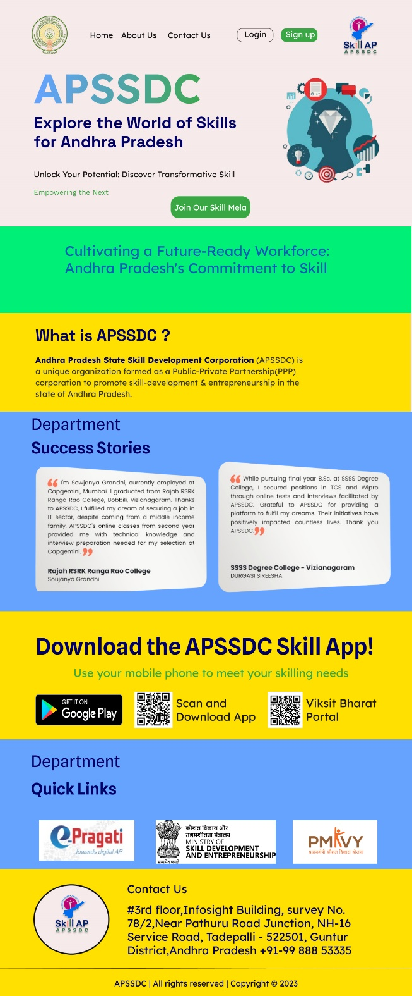

This is sample website of the **APSSDC** this was done in short term of time……………

**Thank you**